

F&S-GO- O&M User guide

Introduction

This document explains how to use AssetWorks Mobile Application i.e. FiRE O&M alternatively called as GO O&M. O&M stands for Operations & Maintenance.

Table of Contents
Introduction 2
1. Install GO O&M application 3
2. Login to GO O&M 8
3. View Work order Phase 10
4. Change Work Order Phase Status 15
5. Add a Note to Work order phase 18
6. Add an Image to Work order phase 23

Change log

Date | Changes | Author
02/28/2019 | Initial Draft | Kanchan Bulbule

Install GO O&M application

Follow below steps in order.
- Open App Catalog in device. Image 1.1
- Search for FiRE/GO Operations and Maint. Image 1.2
- Click Install Image 1.3
- Installation will begin Image 1.4
- Application will be available. Image 1.5

Application will be installed
Image 1.1
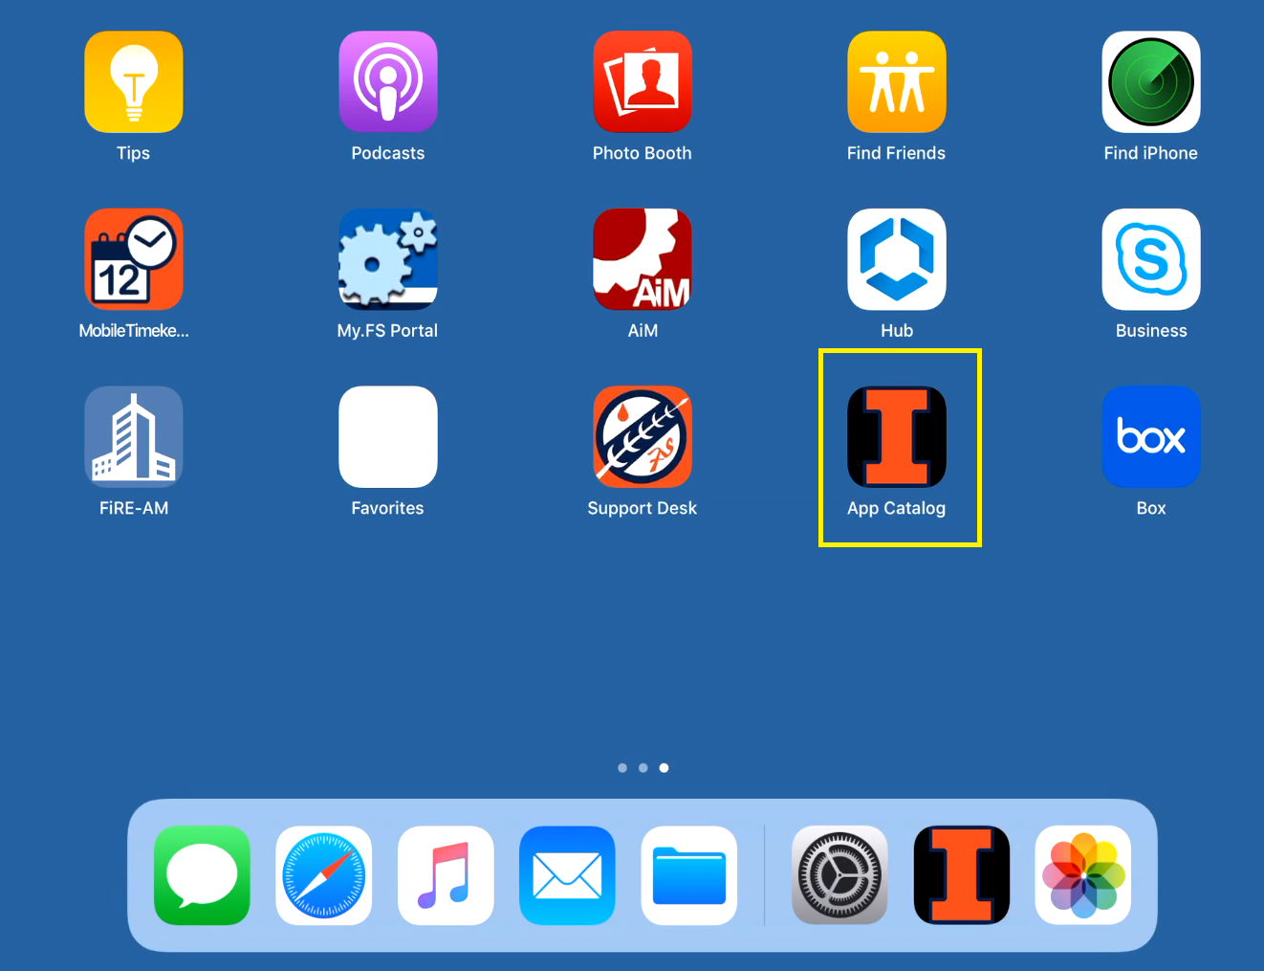
Image 1.2
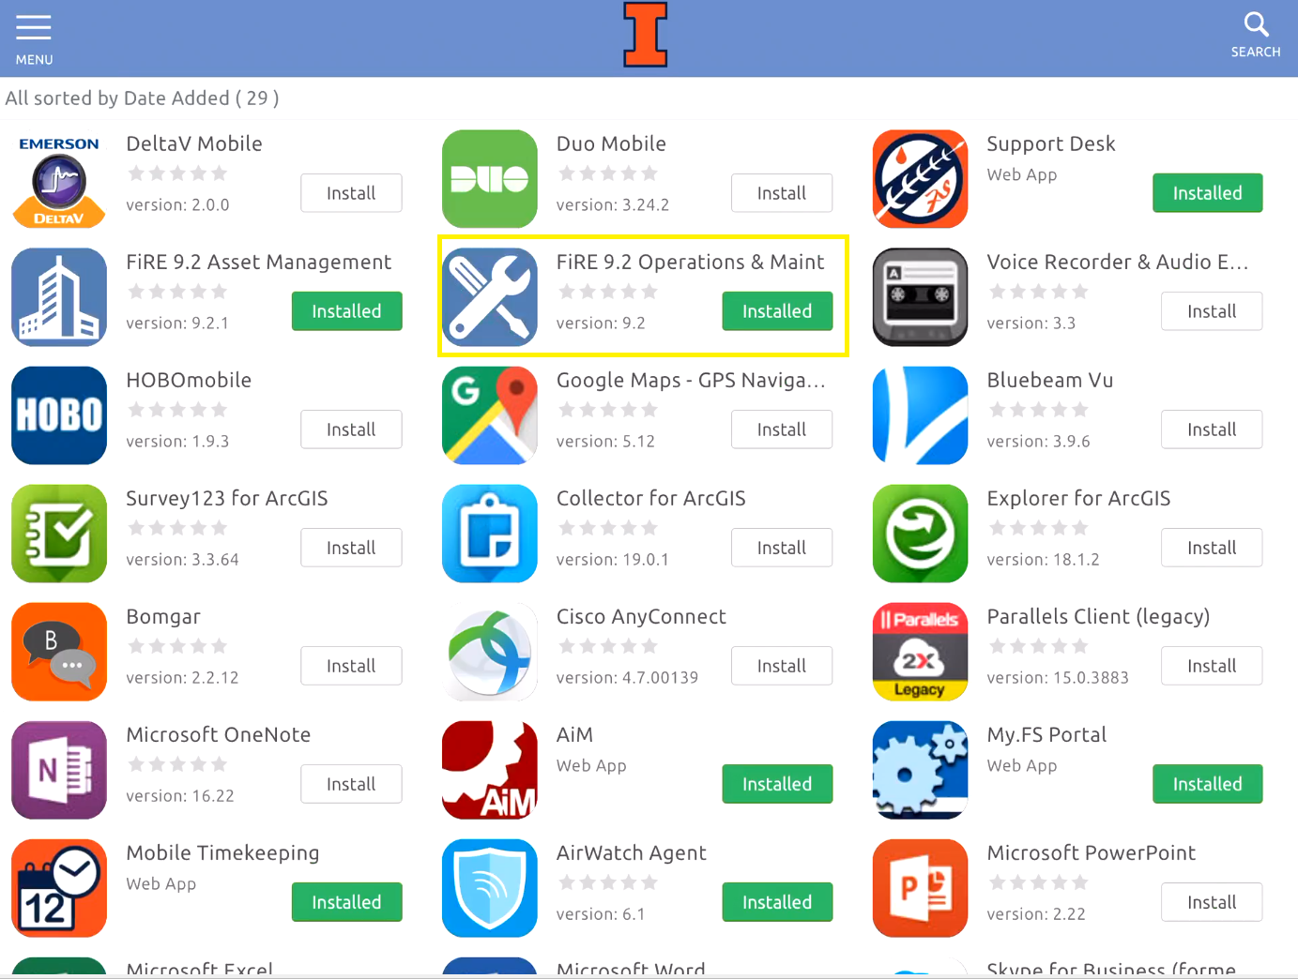

Image 1.3
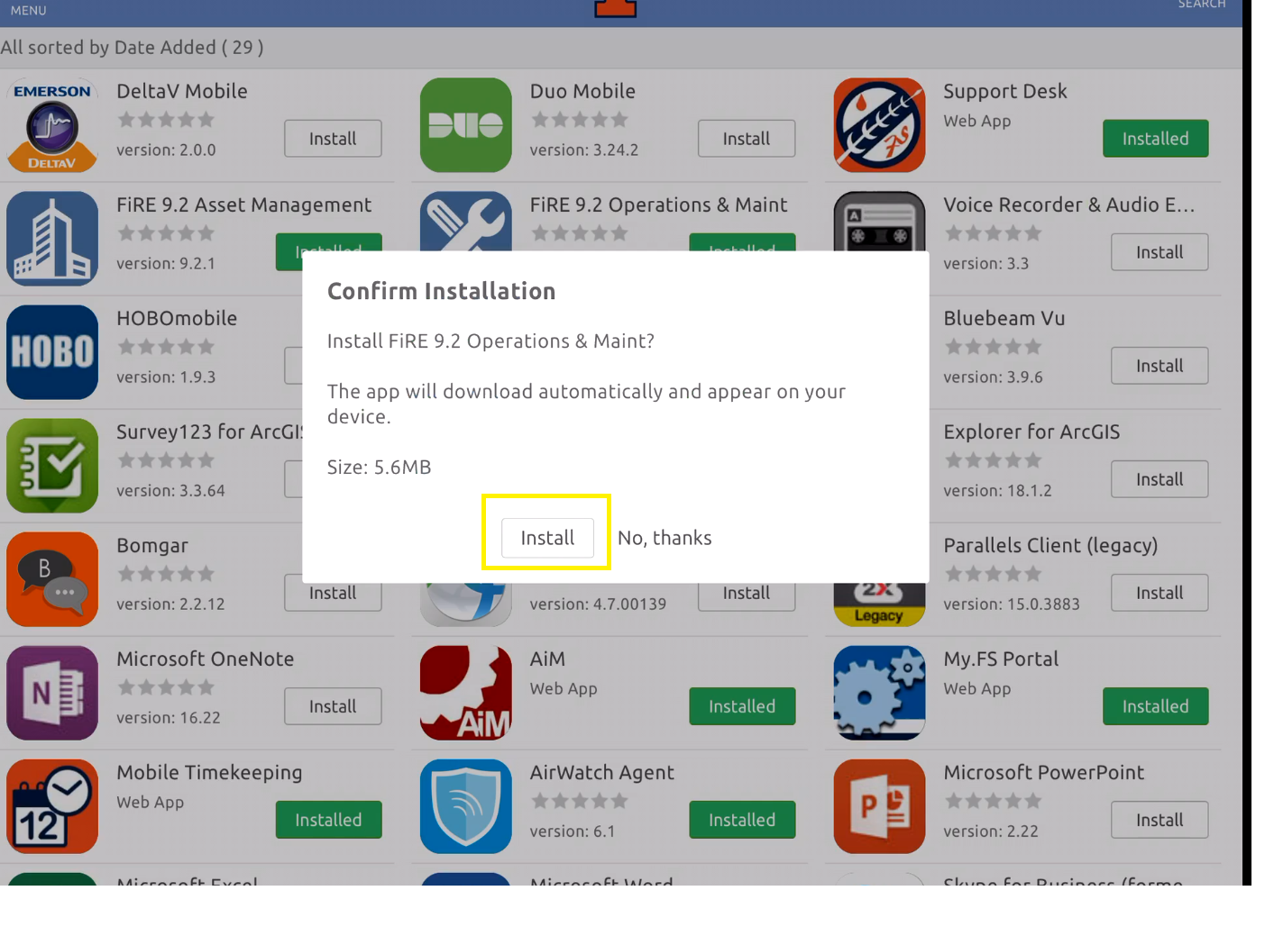

Image 1.4
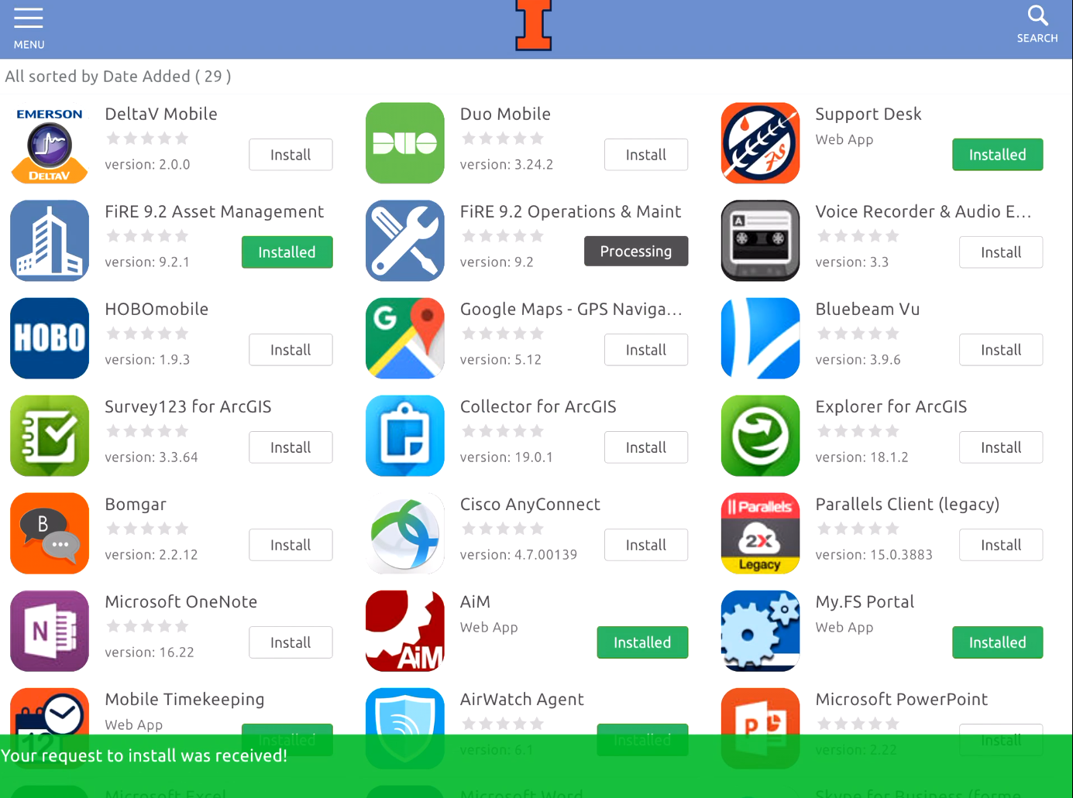

Image 1.5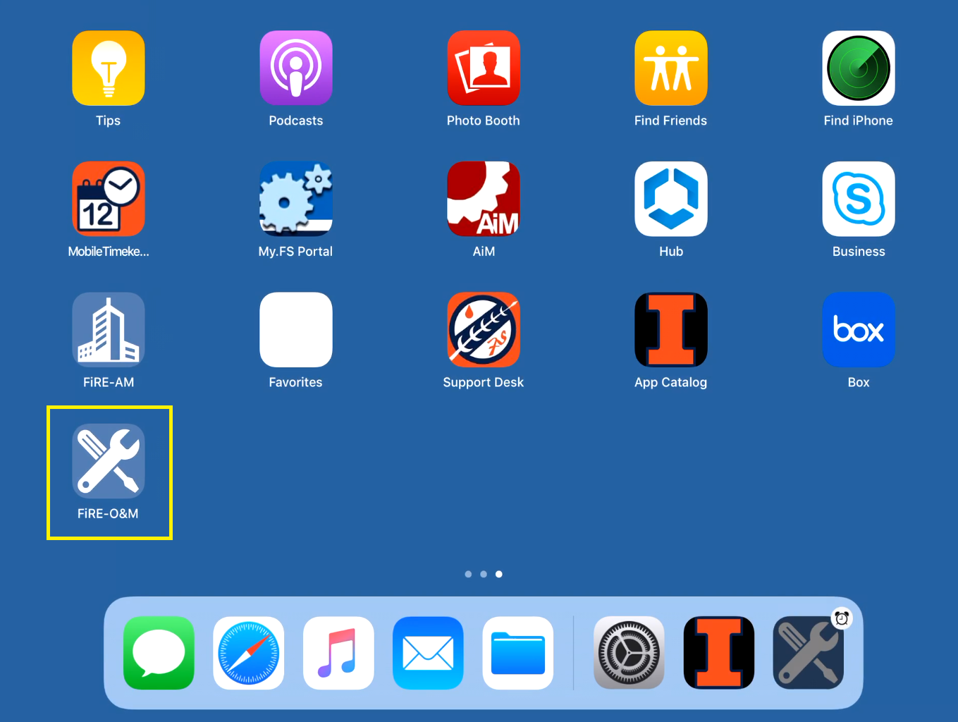

Login to GO O&M
- Click on the FiRE O&M
- Login with your netID and password. Image 2.1
- The URL should be populated already . It should say URL -https://aimgo.fs.illinois.edu/fmax
- Click on work management. Image 2.2
- Then queue tab. It will list all work orders assigned to yourself. Image 2.3

Image 2.1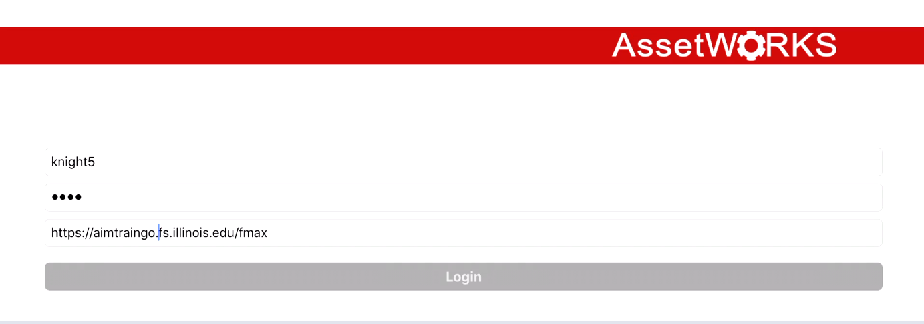
Image 2.2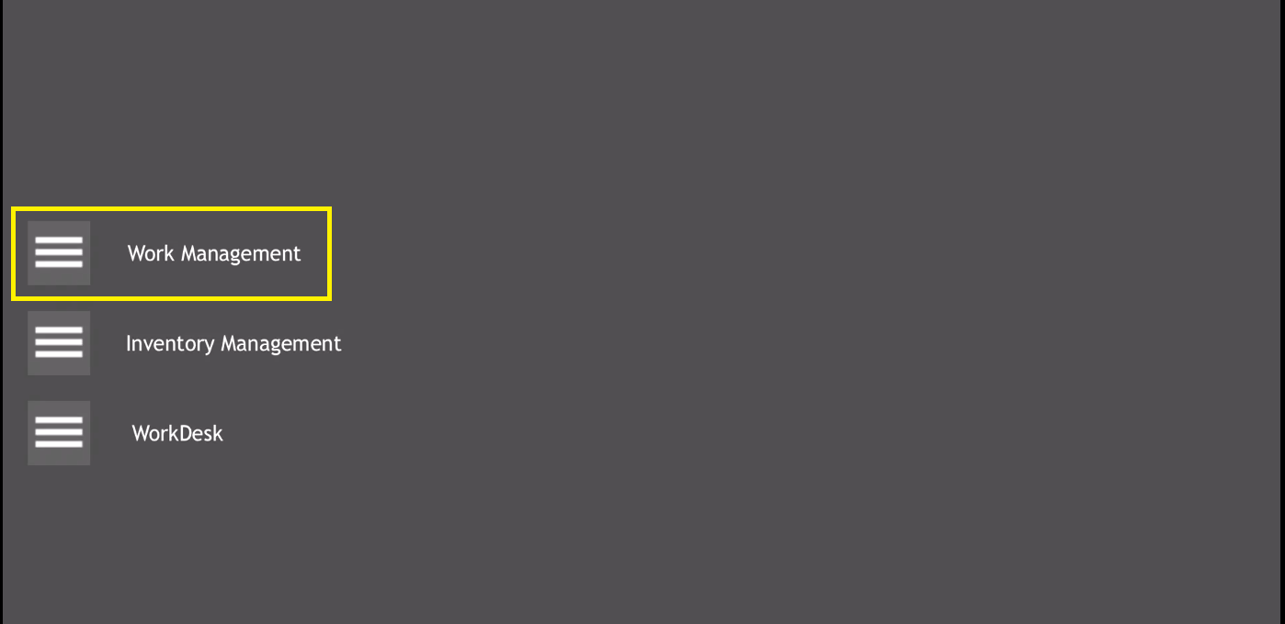
Image 2.3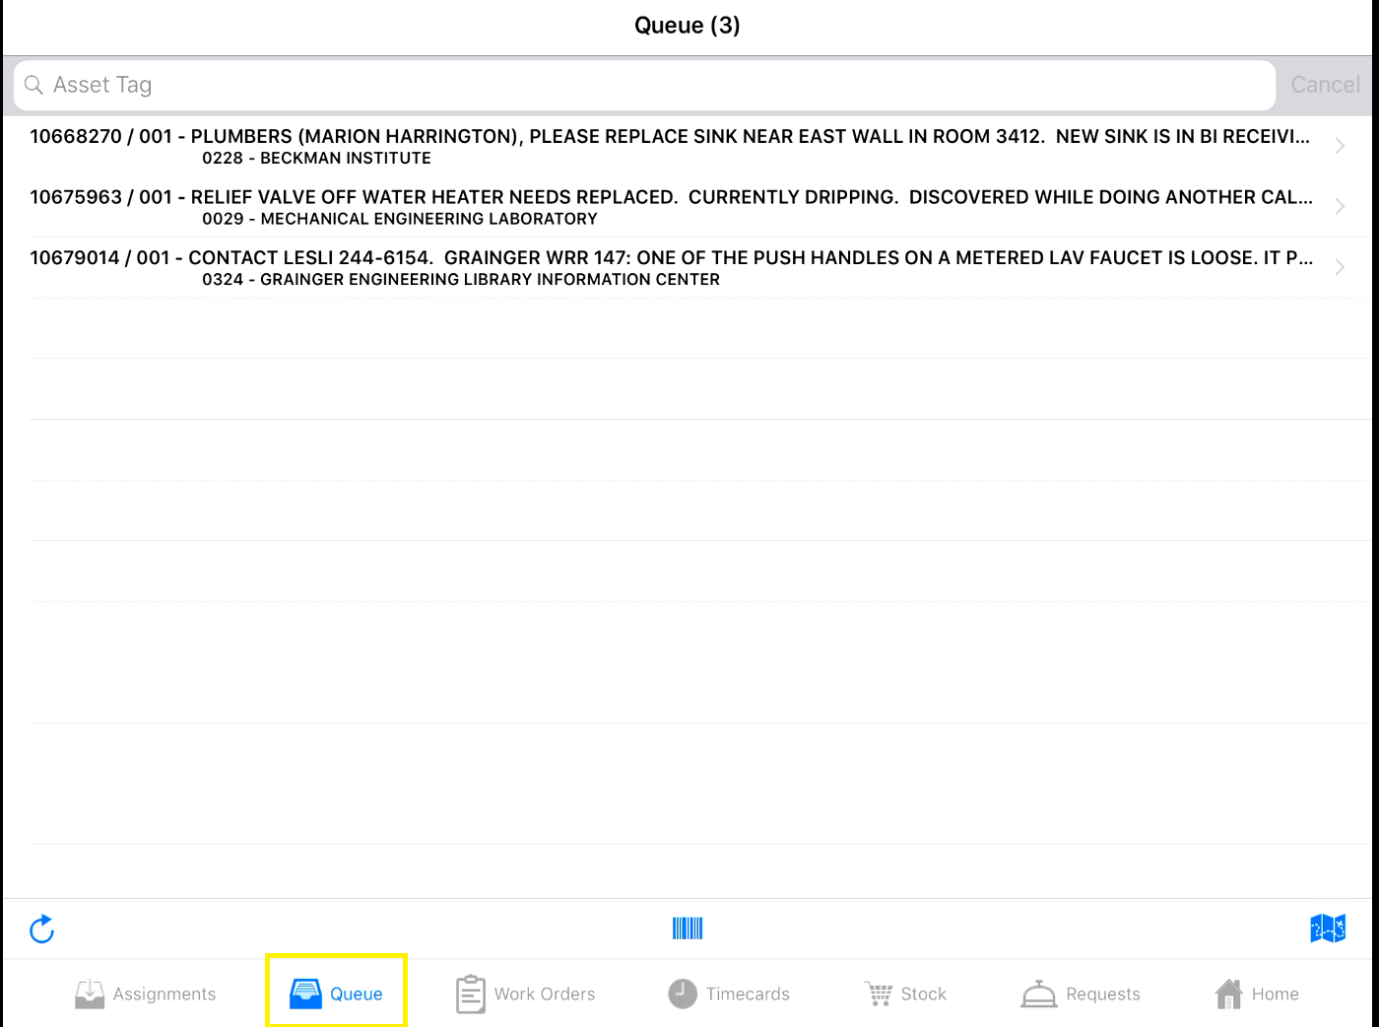

View Work order Phase
- Select desired work order phase. Image 3.1
- It will open and all information available on phase. Image 3.2
- To see information at work order header level, click on the arrow next to work order. Image 3.3
- Work order information is shown. Image 3.4
- To go back , click on phase. Image 3.5

Image 3.1
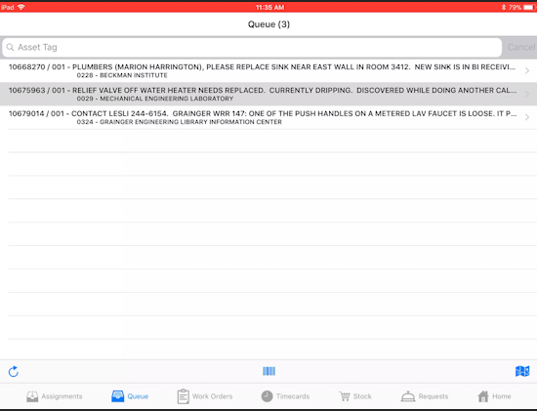
Image 3.2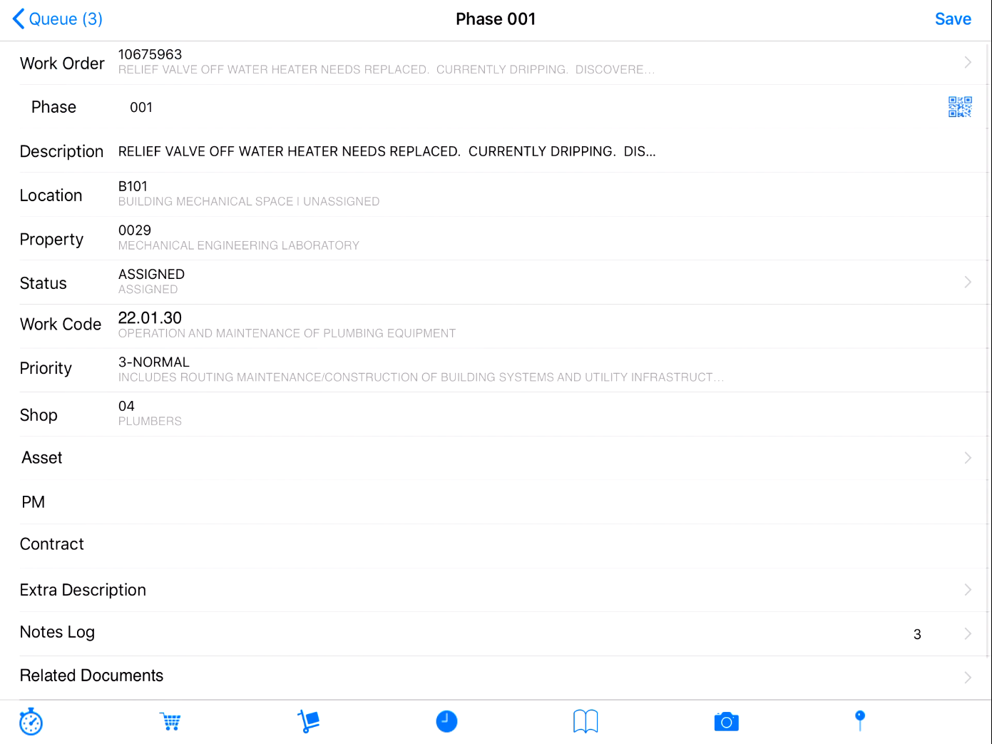
Image 3.3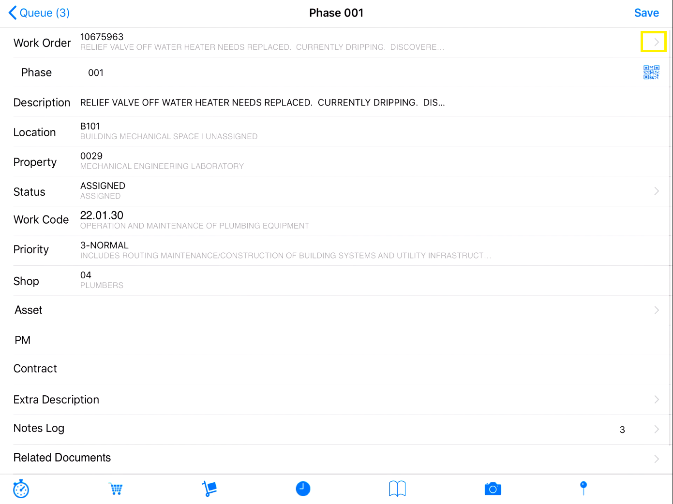
Image 3.4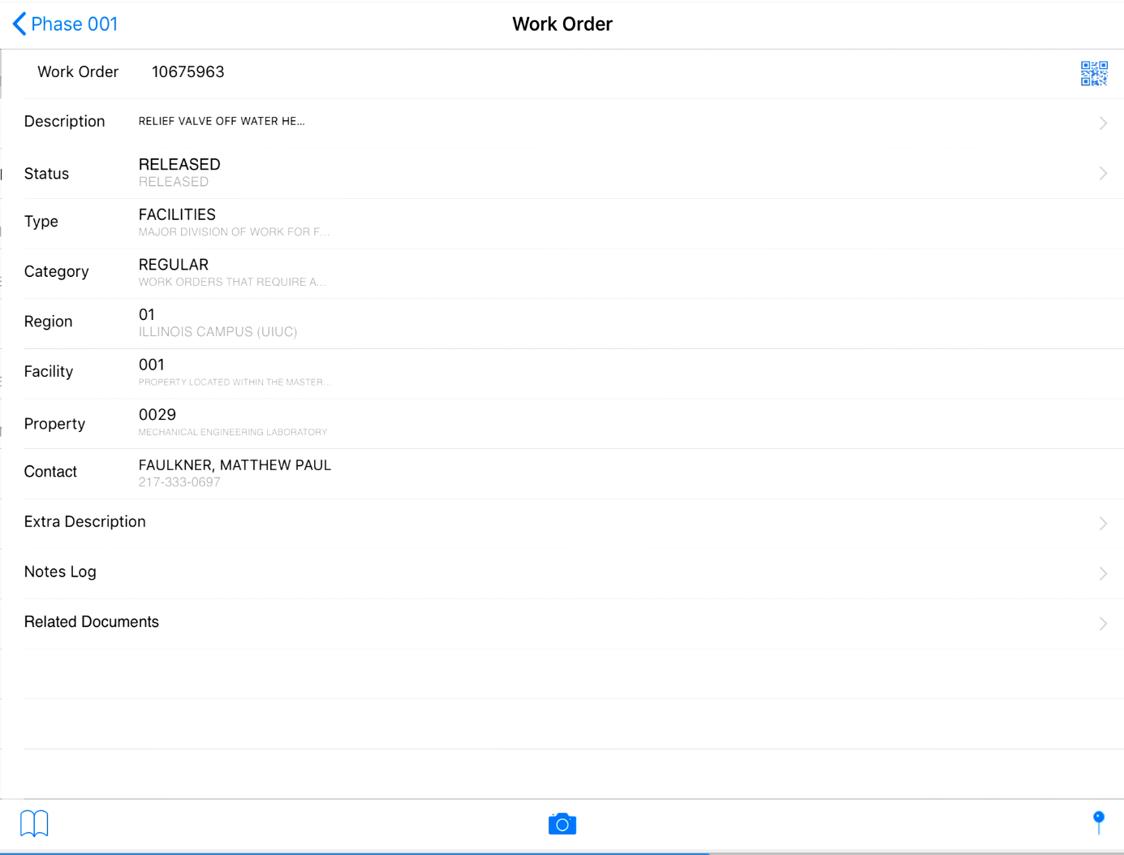
Image 3.5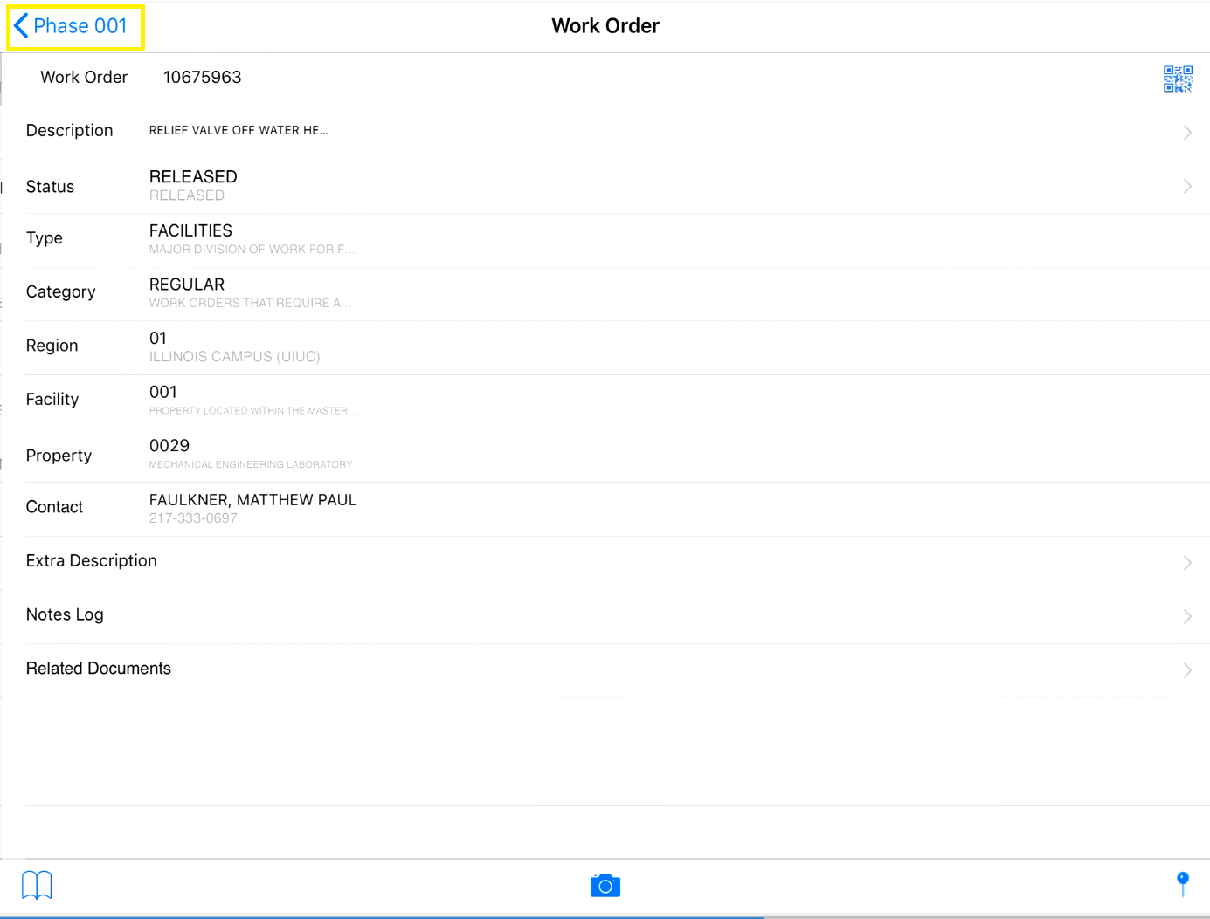

Change Work Order Phase Status
- Click on the arrow next to status. Image 4.1
- Select the new work order phase status. Image 4.2
- Click save. Image 4.3

Image 4.1
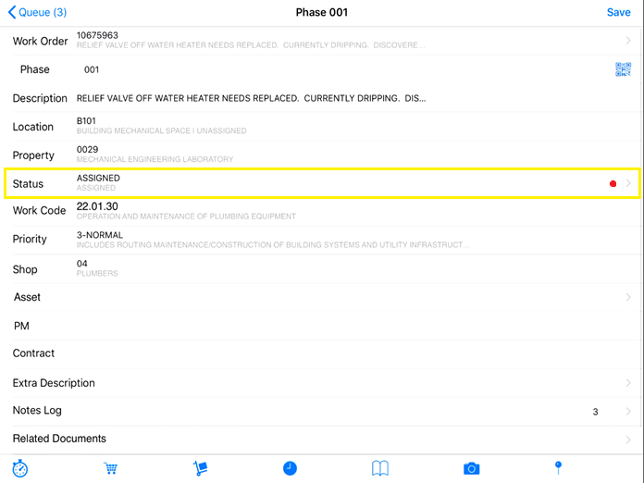
Image 4.2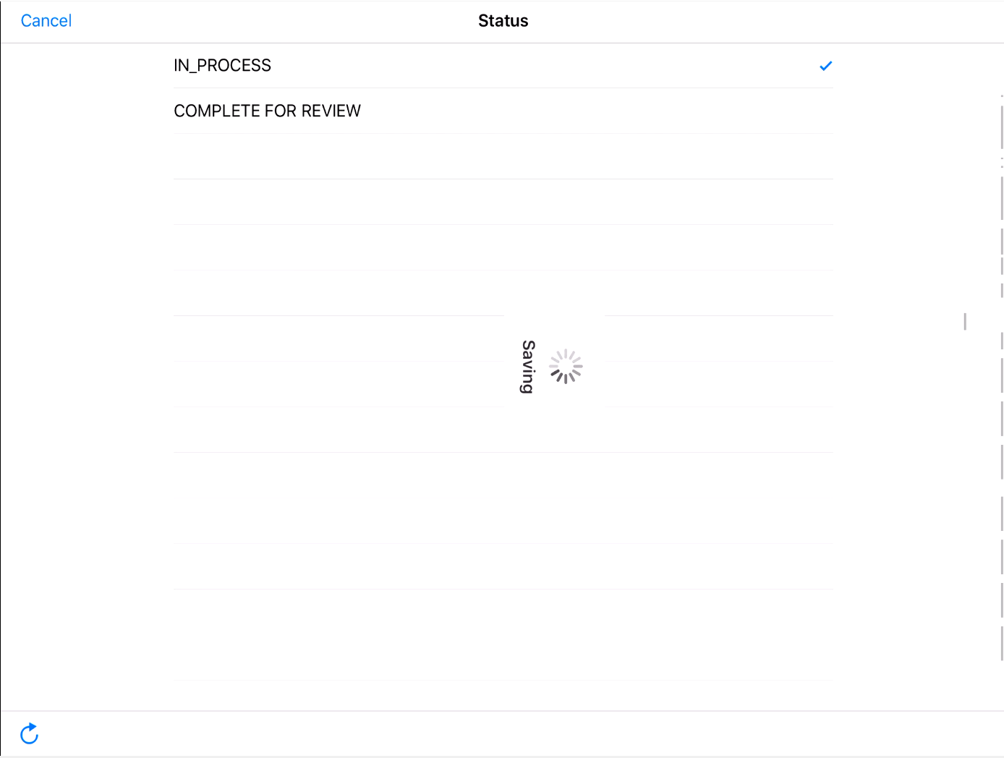
Image 4.3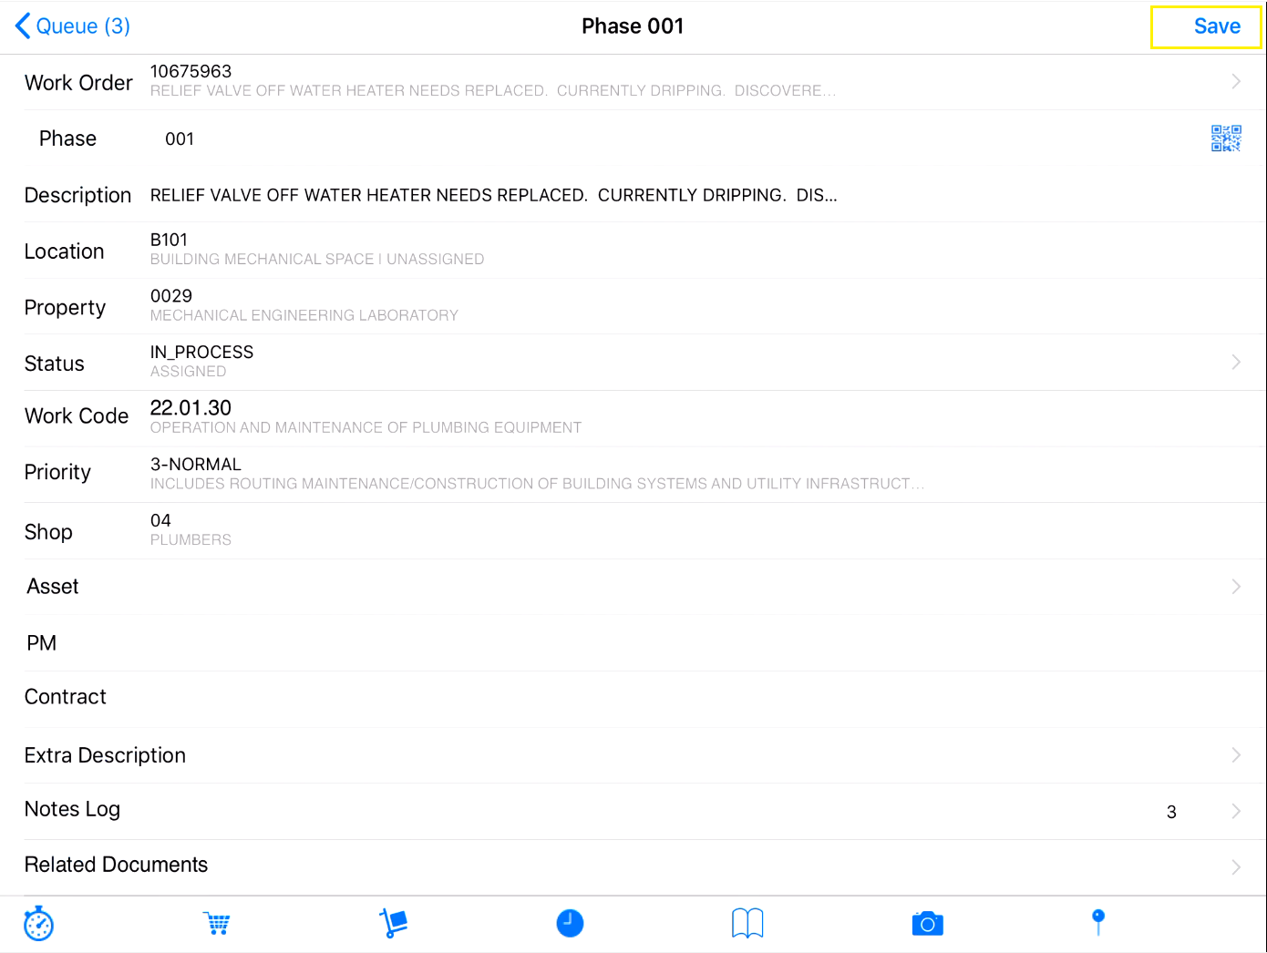

Add a Note to Work order phase
- Click on arrow next to notes log. The number beside arrow tells current count of notes. Image 5.1
- Click on top “+” sign. Image 5.2
- Select note type from list by selecting arrow. Image 5.3 and Image 5.3.1
- Click on blank space to activate keyboard. Image 5.4
- Type in notes using keyboard or use microphone button to talk in. Image 5.5
- Click on save. Image 5.6
- Click on Phase to return. Image 5.7
- Notice the notes count have increased by 1. Image 5.8
Image 5.1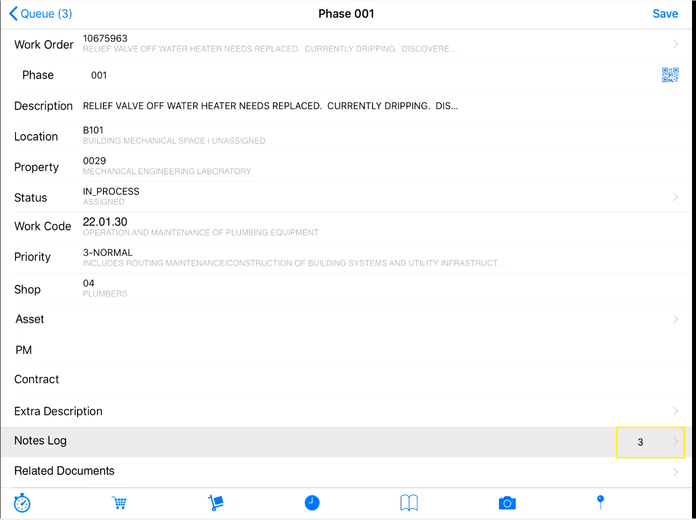
Image 5.2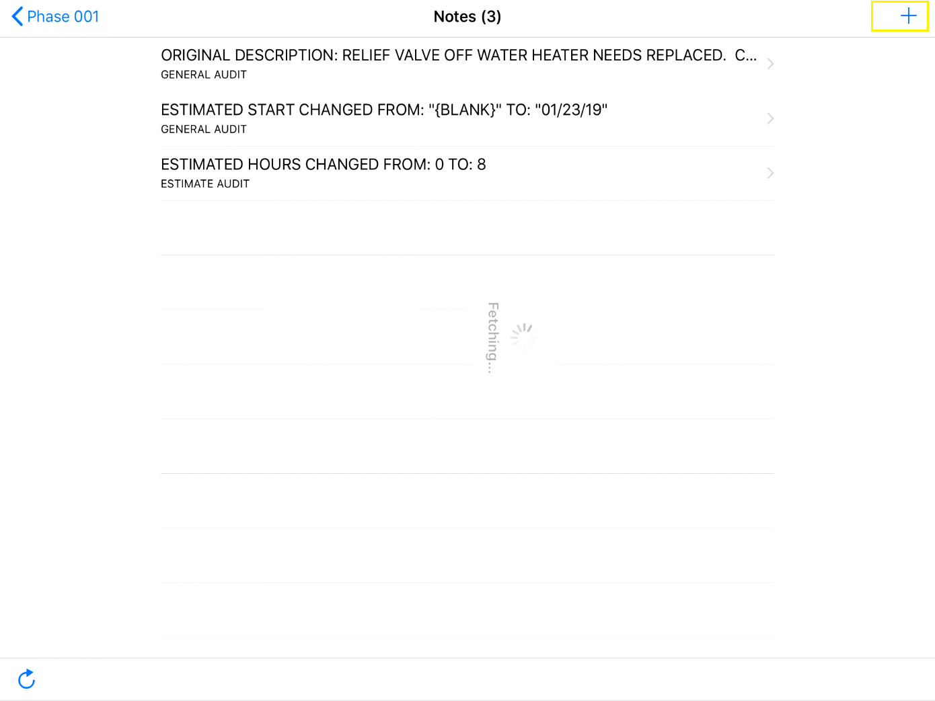

Image 5.3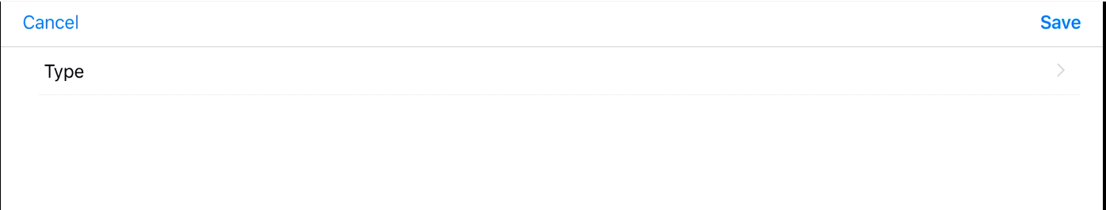
Image 5.3.1
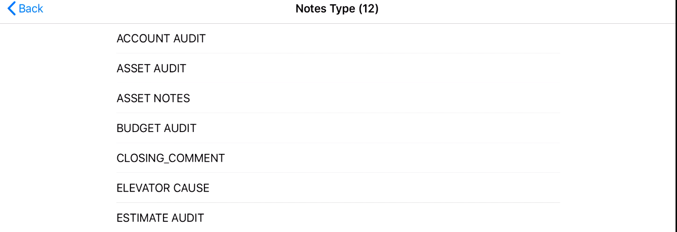
Image 5.4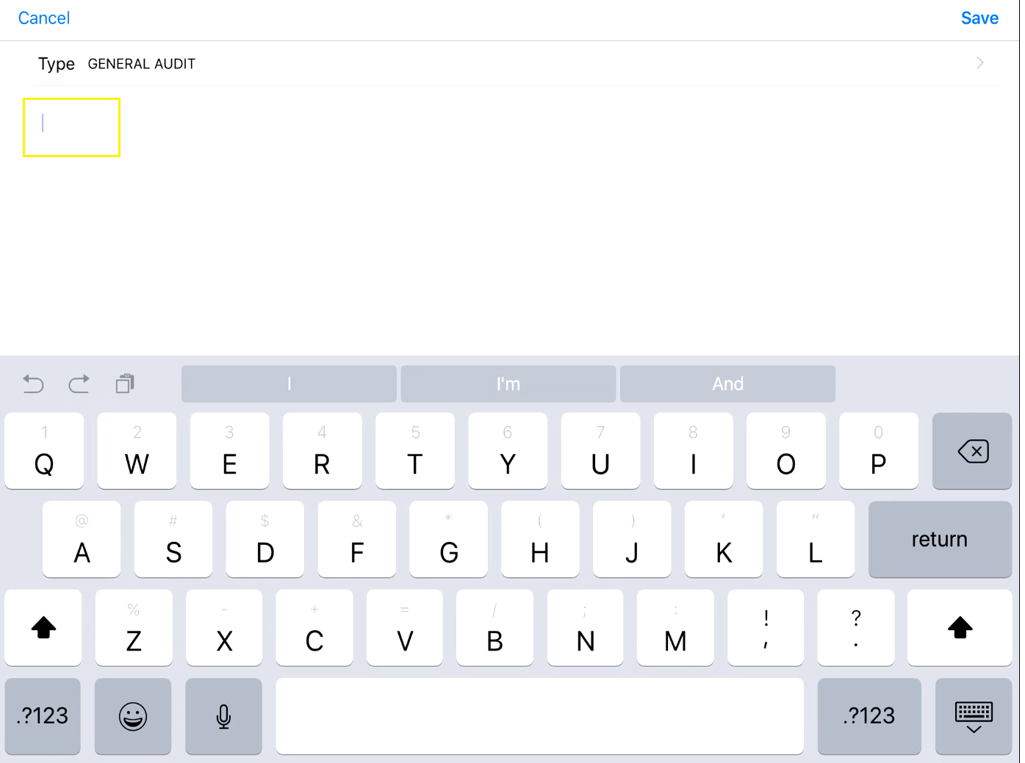
Image 5.5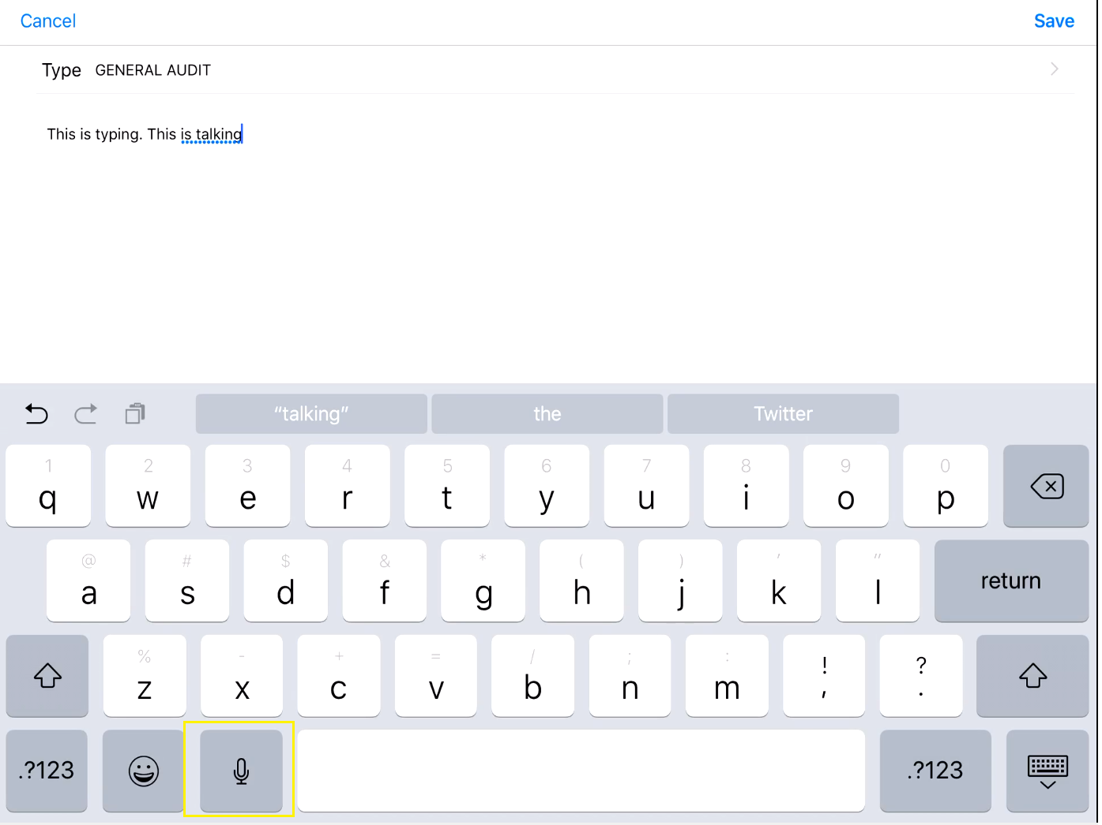
Image 5.6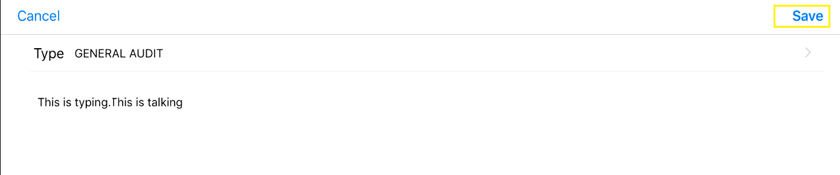
Image 5.7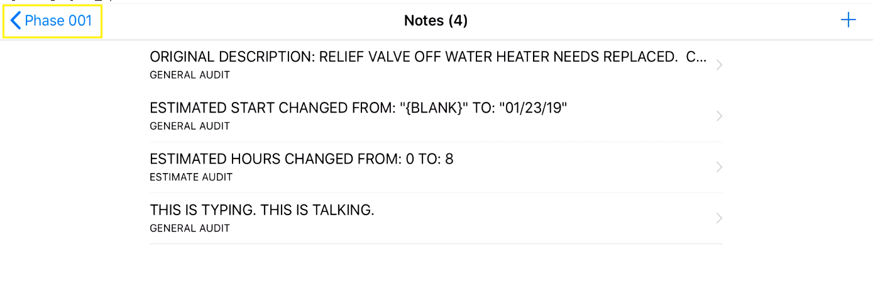
Image 5.8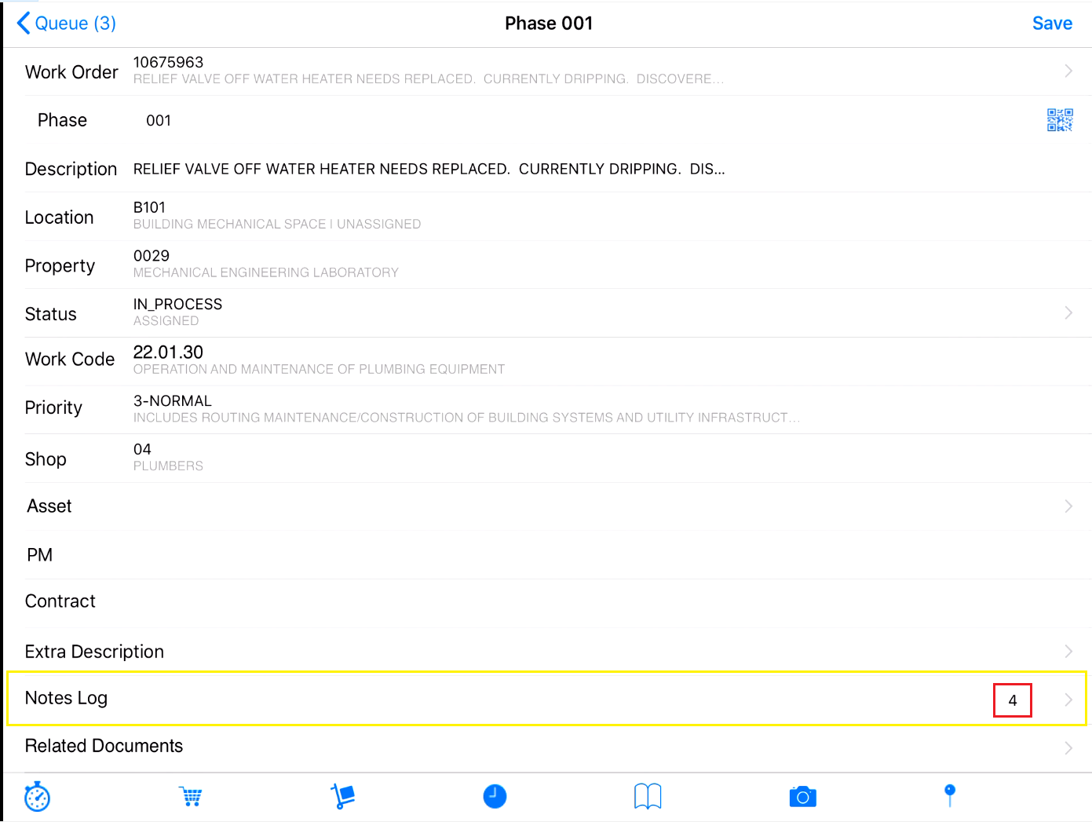

Add an Image to Work order phase
- Click on the “camera” icon to start camera. Image 6.1
- Select “Take Photo”. Image 6.2
  - If question pop up for accessing camera, then click OK.
- Press white button to capture the photo. Image 6.3
- Select Use Photo to select the current picture or Image 6.4
  - Retake to redo
- Add Image Name and Description. Use keyboard to type or “Microphone” to talk into. Image 6.5
- Click save. Image 6.6
- It will be attached under related document. Image 6.7. Click on arrow next to view the image.
Image 6.1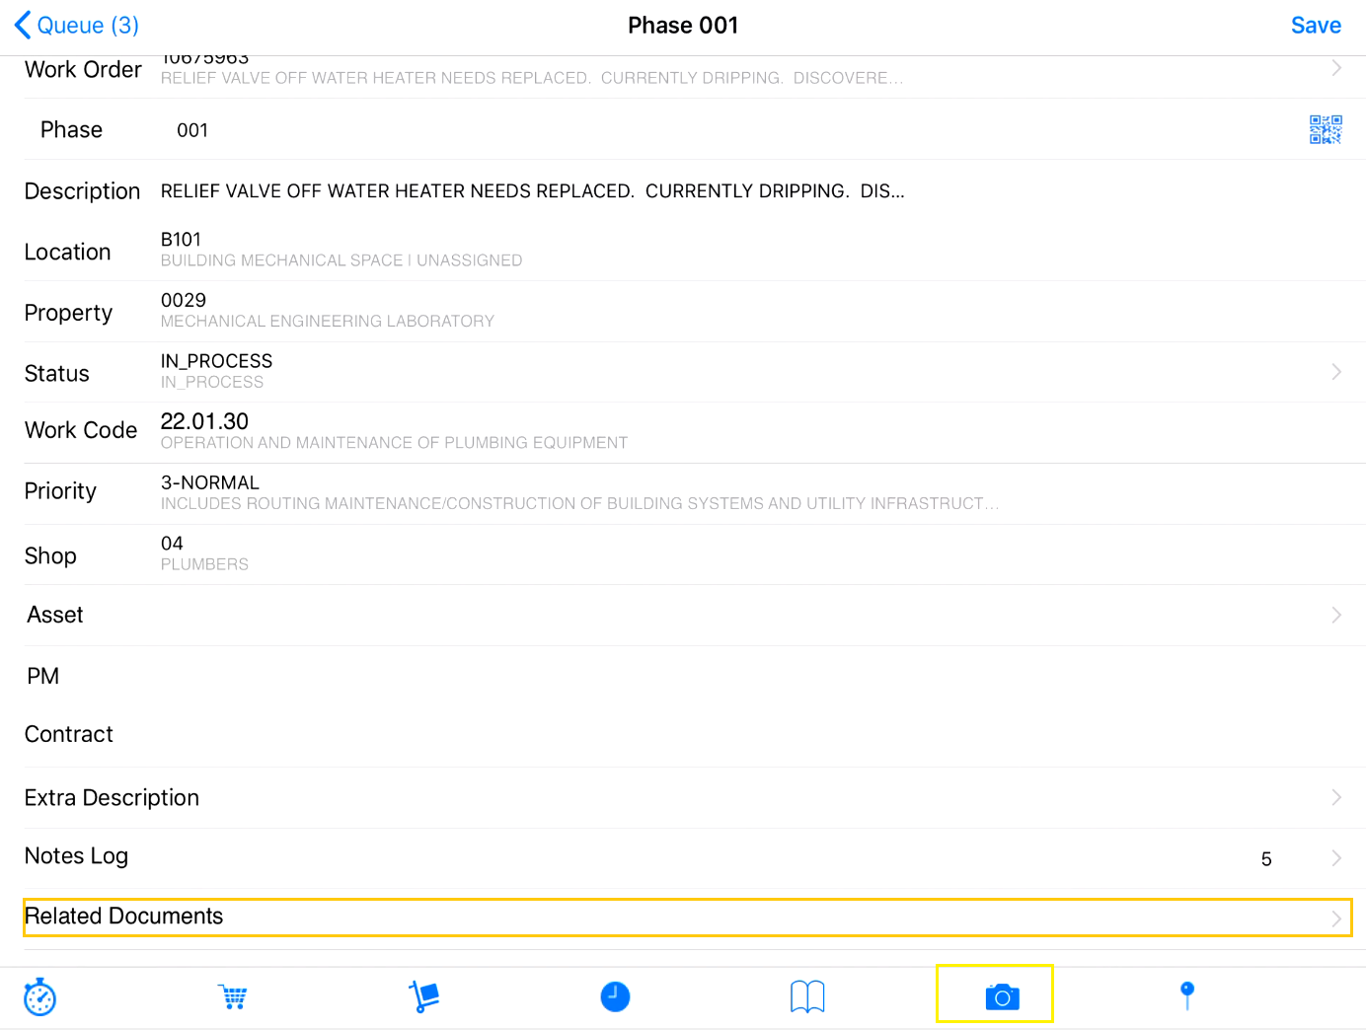
Image 6.2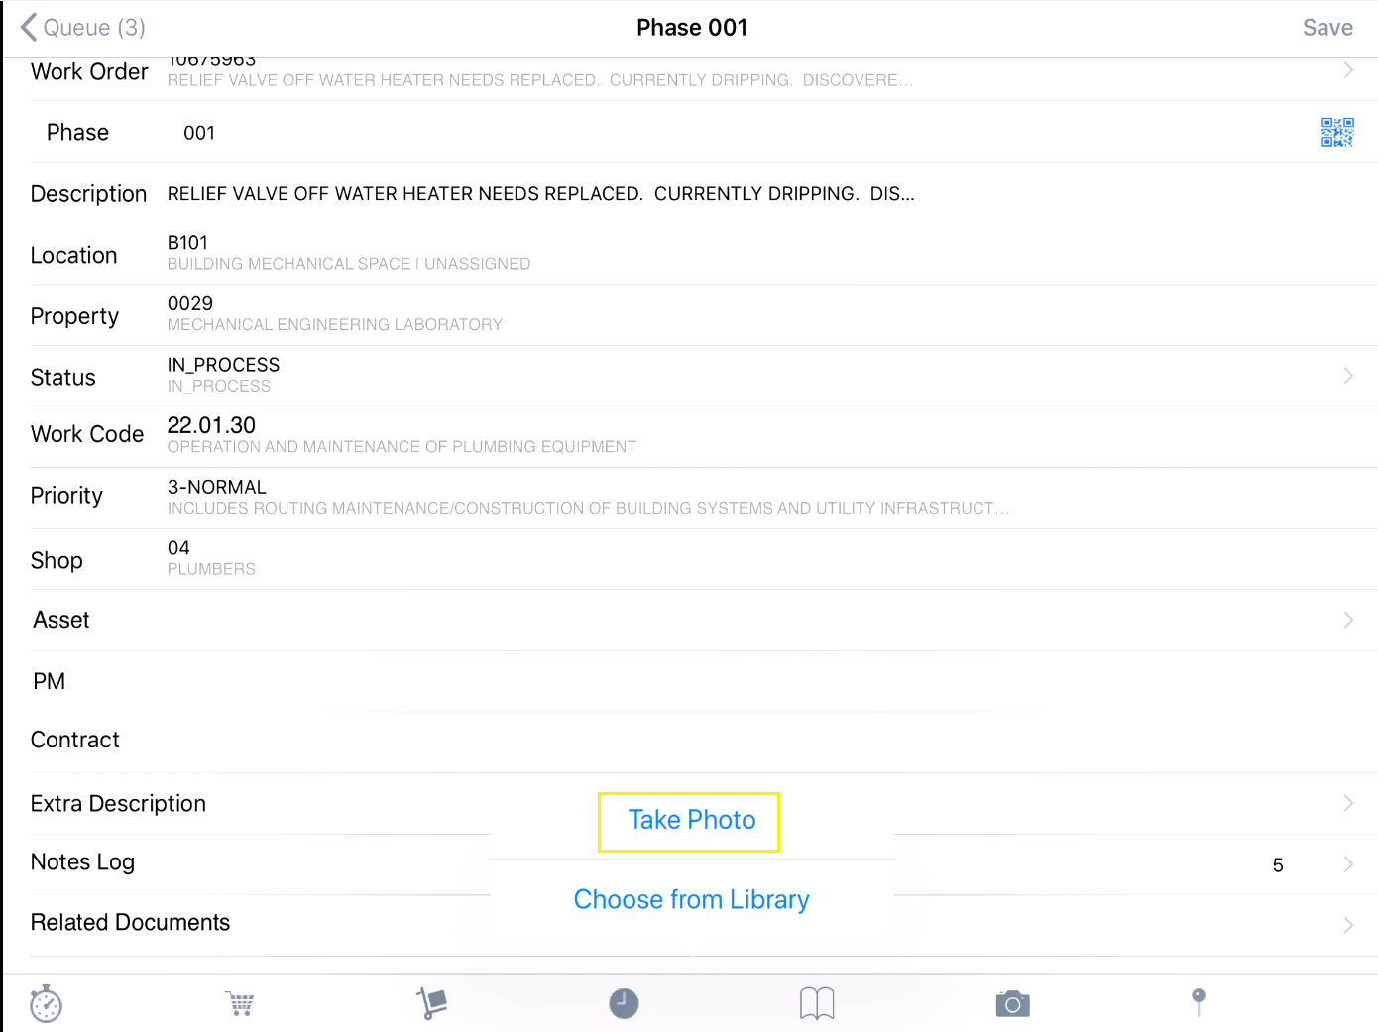

Image 6.3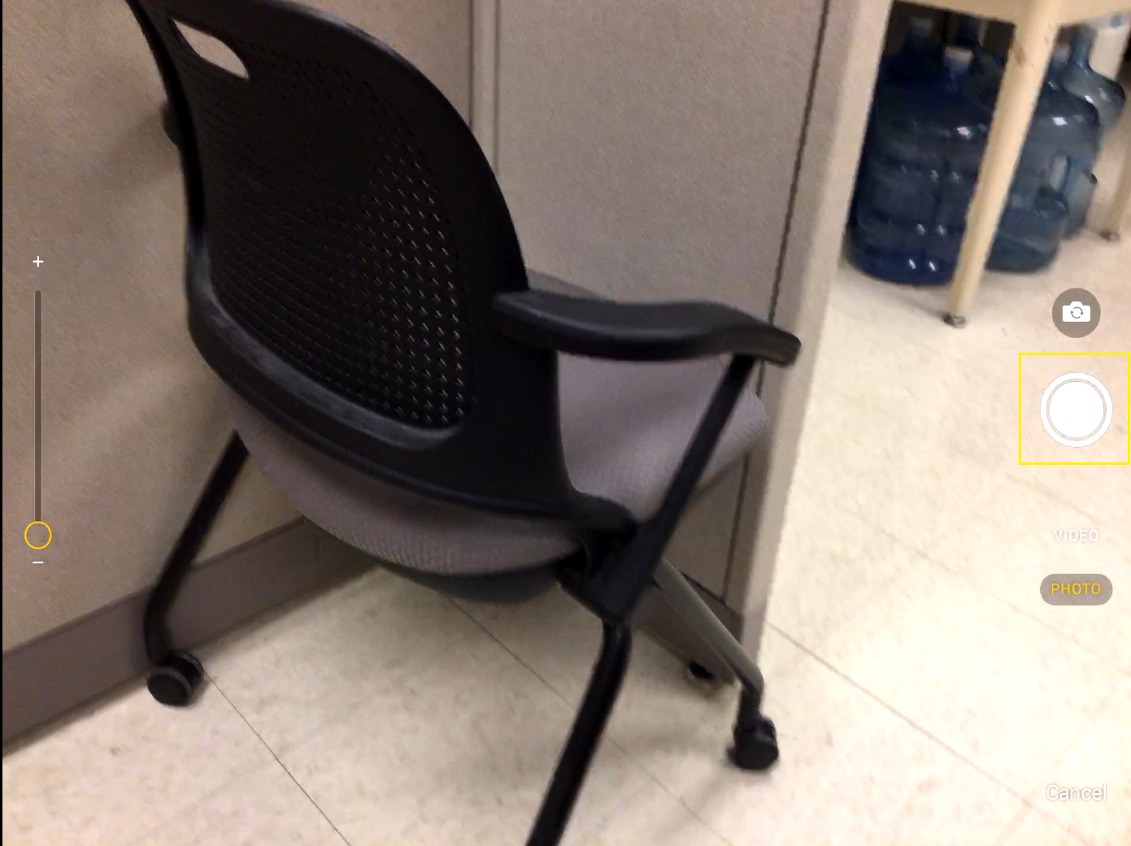
Image 6.4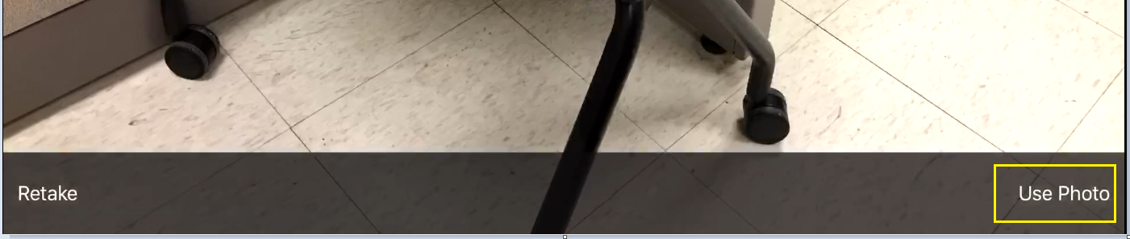
Image 6.5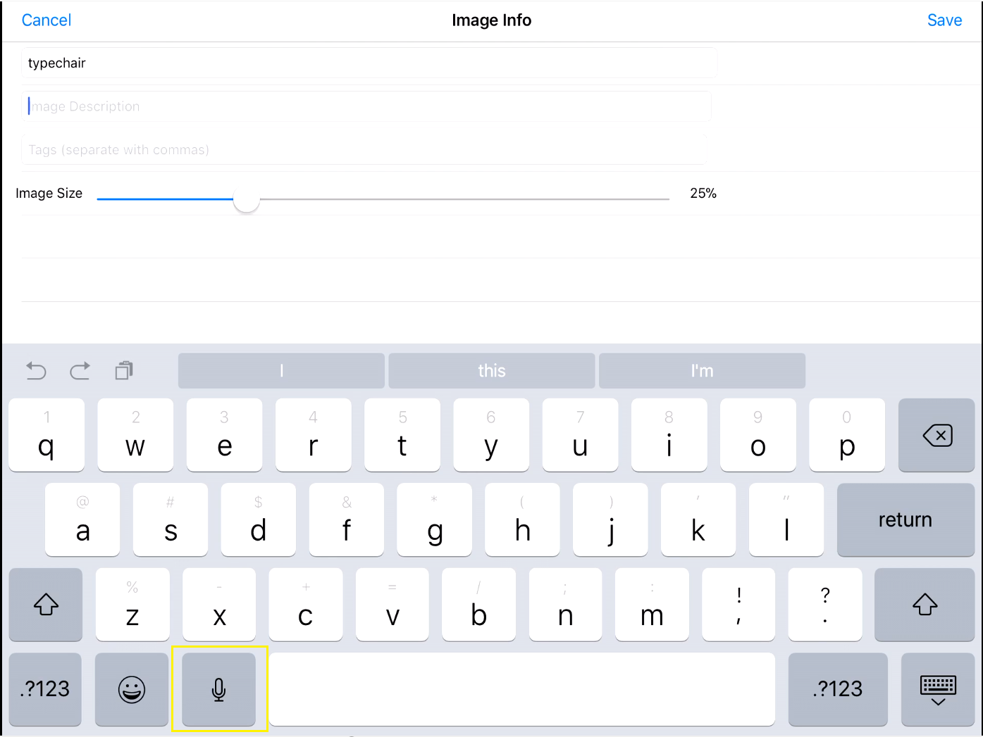
Image 6.6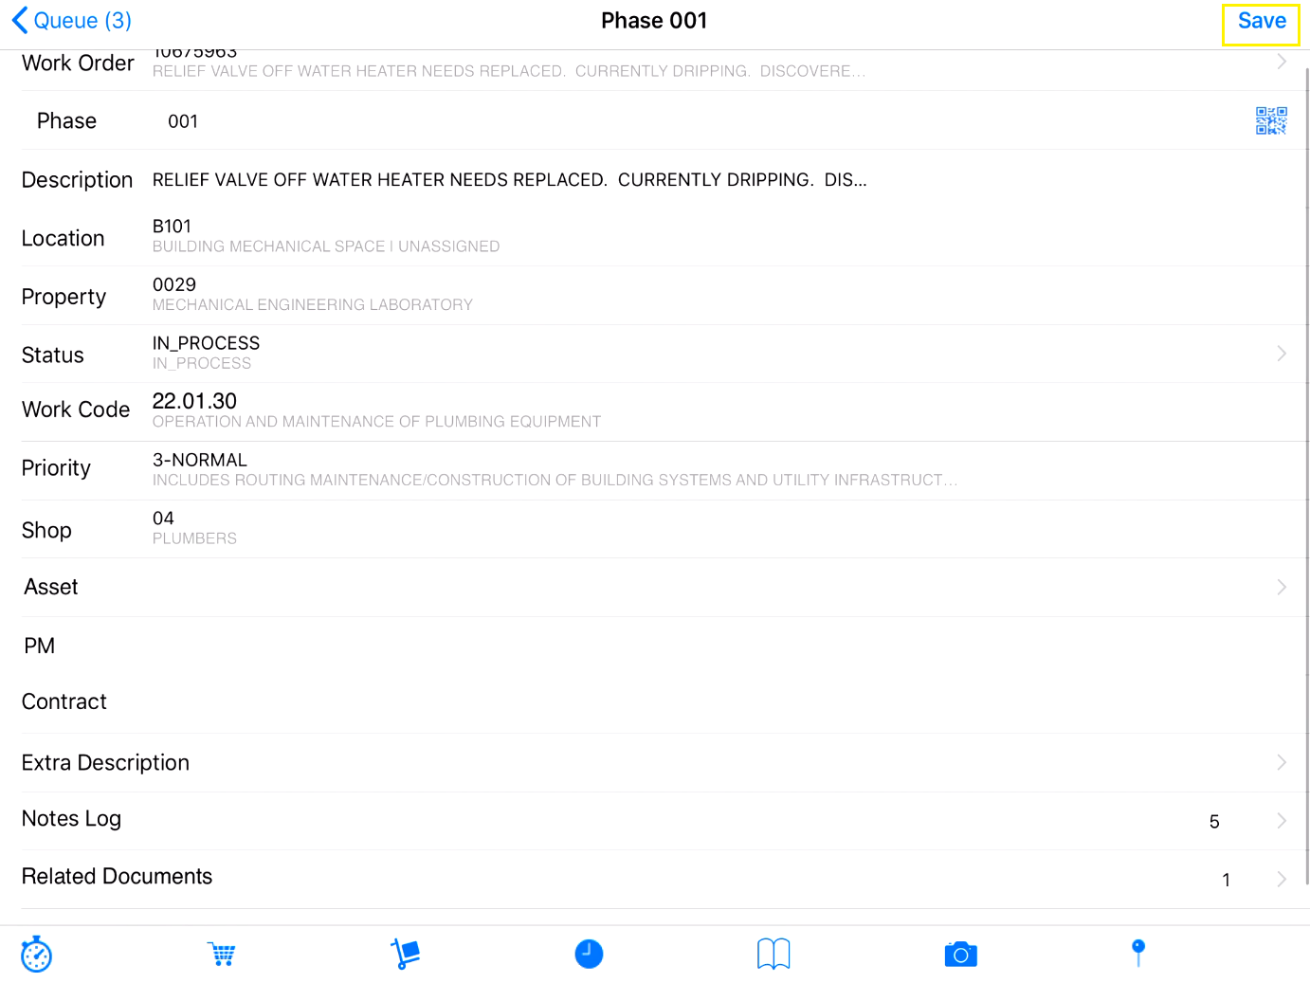
Image 6.7
